Design Principles - High Cohesion
# Source: AI Source: Provided by: [Data Path: Persons Table -> ID Column: 1, Name_En Column: Motasem Essam] -> From: [ChatGPT] on [1/23/2026]
High Cohesion is the principle that a module or component should focus on a single, well-defined responsibility, keeping related functions and data together.
👉 Think of it like a well-organized toolbox: all wrenches are in one compartment, all screwdrivers in another.

🔑 Key Points
# Source: AI Source: Provided by: [Data Path: Persons Table -> ID Column: 1, Name_En Column: Motasem Essam] -> From: [ChatGPT] on [1/23/2026]
- Each module does one logical job well
- Related functionality stays together
- Improves readability, maintainability, and testability
- Works best when combined with loose coupling

❌ Bad Example
# Source: AI Source: Provided by: [Data Path: Persons Table -> ID Column: 1, Name_En Column: Motasem Essam] -> From: [ChatGPT] on [1/23/2026]
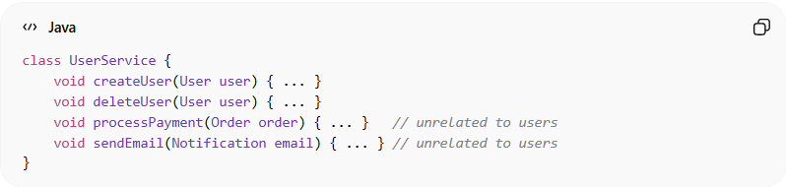
class UserService {
void createUser(User user) { ... }
void deleteUser(User user) { ... }
void processPayment(Order order) { ... } // unrelated to users
void sendEmail(Notification email) { ... } // unrelated to users
}
Problems:
- Single class handles multiple responsibilities
- Hard to maintain or test individual functionalities
- Violates Separation of Concerns

✅ Good Example
# Source: AI Source: Provided by: [Data Path: Persons Table -> ID Column: 1, Name_En Column: Motasem Essam] -> From: [ChatGPT] on [1/23/2026]
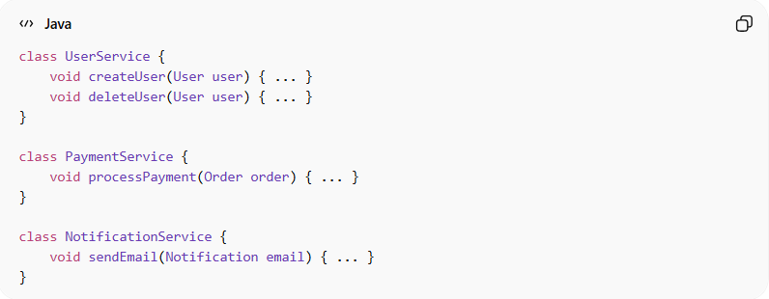
class UserService {
void createUser(User user) { ... }
void deleteUser(User user) { ... }
}

class PaymentService {
void processPayment(Order order) { ... }
}

class NotificationService {
void sendEmail(Notification email) { ... }
}
Benefits:
- Each class/module has clear responsibility
- Easier to test, maintain, and extend
- Reduces complexity and confusion
- Supports reusability of individual modules

⚡ When to Apply
# Source: AI Source: Provided by: [Data Path: Persons Table -> ID Column: 1, Name_En Column: Motasem Essam] -> From: [ChatGPT] on [1/23/2026]
- Always in modular and layered architectures
- Combine with loose coupling for maximum flexibility
- Useful for microservices, APIs, and service classes

